

Tribhuvan University
Faculty of Humanities and Social Sciences
Kirtipur, Kathmandu

A Lab Report
On
Discrete Structure

Submitted by
Name: Bishal Rijal
Roll No: 6 (Six)
Tu Register no: 6-2-1133-50-2019

Submitted to
Narayan Dhamala
Patan Multiple Campus
Patandhoka, Lalitpur

Department of MCA
Affiliated to Tribhuvan University

Sign of Internal Sign of External

………………. ………………...

September- 2026

Contents
1. WAP in python to display truth table of negation. 1
2. WAP in python to display truth table of conjunction. 1
3. WAP in python to display truth table of disjunction. 2
4. WAP in python to display truth table of implication. 2
5. WAP in python to display truth table of bi-implication. 3
6. WAP in python to verify tautology or not. 3
7. WAP in python to find the GCD between two input numbers using Euclidean algorithm. 4
8. WAP in python to find the GCD between two input numbers using Extended Euclidean algorithm. 5
9. WAP in python to solve the given simultaneous congruence using Chinese Remainder theorem. 6
10. WAP in python to test relation properties: Reflexive, Symmetric, Anti-symmetric and Transitive for a given set and Relation. 7
11. WAP in python to represent relation in matrix form for a given set and relation. 8
12. WAP in python to represent relation in digraph form for a given set and relation. 9
13. WAP in python to determine whether the given relation is equivalence relation or not. 10
14. WAP in python to determine whether the given relation is partial order relation or not. 11
15. WAP in python to find the factorial of an input number using recursion. 12
16. WAP in python to find the nth term of Fibonacci sequence using recursion. 12
17. WAP in python to validate inductive proof 13
18. WAP in python to represent adjacency list and visualize using NetworkX. 14
19. WAP In python to represent adjacency matrix and visualize using NetworkX. 15
20. WAP in python to perform tree traversal (pre-order, in-order and post-order). 16
21. WAP in python to find MST using Kruskal’s algorithm. 17
22. WAP in python to construct finite automata that accepts strings only ab and abb. 19

1. WAP in python to display truth table of negation.
print("P\t~P")
print("-" * 10)
for P in [True, False]:
print(P, "\t", not P)
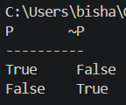

2. WAP in python to display truth table of conjunction.
print("P\tQ\tP AND Q")
print("-" * 20)
for P in [True, False]:
for Q in [True, False]:
print(P, "\t", Q, "\t", P and Q)
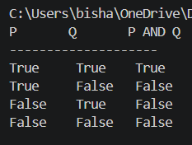

3. WAP in python to display truth table of disjunction.
print("P\tQ\tP OR Q")
print("-" * 20)
for P in [True, False]:
for Q in [True, False]:
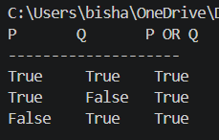
print(P, "\t", Q, "\t", P or Q)

4. WAP in python to display truth table of implication.
print("P\tQ\tP -> Q")
print("-" * 20)
for P in [True, False]:
for Q in [True, False]:
result = (not P) or Q
print(P, "\t", Q, "\t", result)
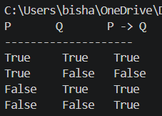

5. WAP in python to display truth table of bi-implication.
print("P\tQ\tP <-> Q")
print("-" * 20)
for P in [True, False]:
for Q in [True, False]:
result = P == Q
print(P, "\t", Q, "\t", result)
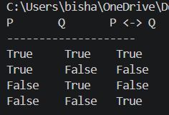

6. WAP in python to verify tautology or not.
# Example: P OR NOT P
is_tautology = True
for P in [True, False]:
result = P or not P
print("P =", P, "Result =", result)
if not result:
is_tautology = False
if is_tautology:
print("The proposition is a tautology.")
else:
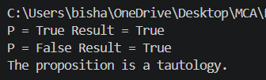
print("The proposition is not a tautology.")

7. WAP in python to find the GCD between two input numbers using Euclidean algorithm.
a = int(input("Enter first number: "))
b = int(input("Enter second number: "))
while b != 0:
a, b = b, a % b
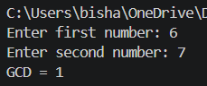
print("GCD =", abs(a))

8. WAP in python to find the GCD between two input numbers using Extended Euclidean algorithm.
def extended_gcd(a, b):
if b == 0:
return a, 1, 0
gcd, x1, y1 = extended_gcd(b, a % b)
x = y1
y = x1 - (a // b) * y1
return gcd, x, y
a = int(input("Enter first number: "))
b = int(input("Enter second number: "))
gcd, x, y = extended_gcd(a, b)
print("GCD =", gcd)
print("x =", x)
print("y =", y)
print("Verification:", a, "*", x, "+", b, "*", y, "=", gcd)
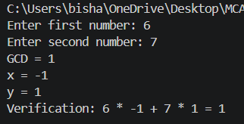

9. WAP in python to solve the given simultaneous congruence using Chinese Remainder theorem.
def extended_gcd(a, b):
if b == 0:
return a, 1, 0

gcd, x1, y1 = extended_gcd(b, a % b)

x = y1
y = x1 - (a // b) * y1

return gcd, x, y

def mod_inverse(a, m):
gcd, x, y = extended_gcd(a, m)

if gcd != 1:
return None

return x % m

n = int(input("Enter number of congruences: "))

a = []
m = []

for i in range(n):
a.append(int(input(f"Enter remainder a[{i+1}]: ")))
m.append(int(input(f"Enter modulus m[{i+1}]: ")))

M = 1
for value in m:
M *= value

x = 0

for i in range(n):
Mi = M // m[i]
yi = mod_inverse(Mi, m[i])
x += a[i] * Mi * yi

x = x % M
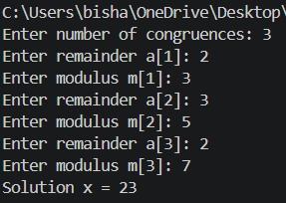
print("Solution x =", x)
print("Modulo =", M)

10. WAP in python to test relation properties: Reflexive, Symmetric, Anti-symmetric and Transitive for a given set and Relation.
A = {1, 2, 3}

R = {(1, 1), (2, 2), (3, 3), (1, 2), (2, 1)}

reflexive = all((a, a) in R for a in A)

symmetric = all(
(b, a) in R
for (a, b) in R
)

antisymmetric = all(
a == b or (b, a) not in R
for (a, b) in R
)

transitive = all(
(a, c) in R
for (a, b) in R
for (c, d) in R
if b == c
)

print("Relation:", R)
print("Reflexive:", reflexive)
print("Symmetric:", symmetric)
print("Anti-symmetric:", antisymmetric)
print("Transitive:", transitive)
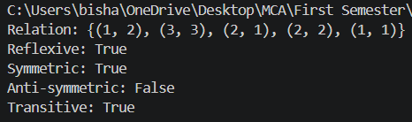

11. WAP in python to represent relation in matrix form for a given set and relation.
A = [1, 2, 3]

R = {(1, 1), (1, 2), (2, 2), (3, 3)}

print("Relation Matrix:")

for i in A:
for j in A:
if (i, j) in R:
print(1, end=" ")
else:
print(0, end=" ")
print()
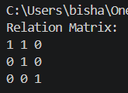

12. WAP in python to represent relation in digraph form for a given set and relation.

import networkx as nx
import matplotlib.pyplot as plt

A = [1, 2, 3]

R = {(1, 1), (1, 2), (2, 3), (3, 1)}

G = nx.DiGraph()

G.add_nodes_from(A)
G.add_edges_from(R)

nx.draw(
G,
with_labels=True,
node_size=2000,
arrows=True
)

plt.title("Digraph of Relation")
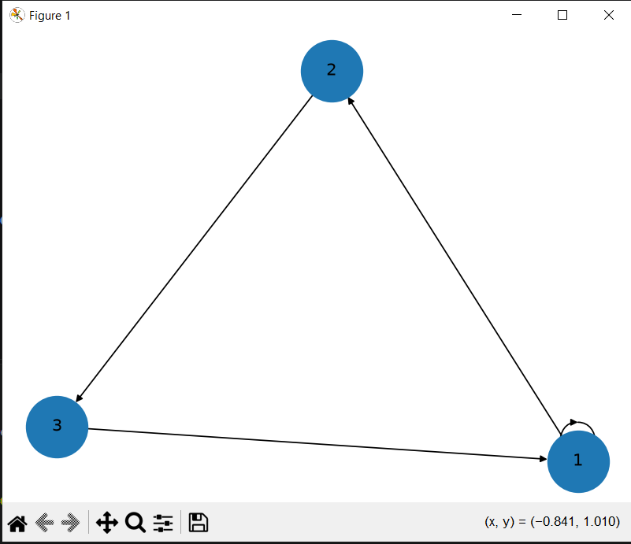
plt.show()

13. WAP in python to determine whether the given relation is equivalence relation or not.
A = {1, 2, 3}

R = {(1, 1), (2, 2), (3, 3),
(1, 2), (2, 1),
(2, 3), (3, 2),
(1, 3), (3, 1)}

reflexive = all((a, a) in R for a in A)

symmetric = all(
(b, a) in R
for (a, b) in R
)

transitive = all(
(a, c) in R
for (a, b) in R
for (c, d) in R
if b == c
)

if reflexive and symmetric and transitive:
print("The relation is an Equivalence Relation.")
else:
print("The relation is NOT an Equivalence Relation.")
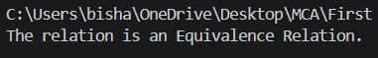

14. WAP in python to determine whether the given relation is partial order relation or not.
A = {1, 2, 3}

R = {(1, 1), (2, 2), (3, 3),
(1, 2), (1, 3), (2, 3)}

reflexive = all((a, a) in R for a in A)

antisymmetric = all(
a == b or (b, a) not in R
for (a, b) in R
)

transitive = all(
(a, c) in R
for (a, b) in R
for (c, d) in R
if b == c
)

if reflexive and antisymmetric and transitive:
print("The relation is a Partial Order Relation.")
else:
print("The relation is NOT a Partial Order Relation.")

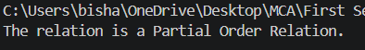

15. WAP in python to find the factorial of an input number using recursion.
def factorial(n):
if n == 0 or n == 1:
return 1
return n * factorial(n - 1)

n = int(input("Enter a number: "))

print("Factorial =", factorial(n))

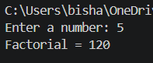

16. WAP in python to find the nth term of Fibonacci sequence using recursion.

def fibonacci(n):
if n == 0:
return 0
elif n == 1:
return 1
else:
return fibonacci(n - 1) + fibonacci(n - 2)

n = int(input("Enter n: "))

print("Fibonacci term =", fibonacci(n))

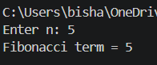

17. WAP in python to validate inductive proof
# Example: 1 + 2 + ... + n = n(n+1)/2

def validate_induction(n):
lhs = sum(range(1, n + 1))
rhs = n * (n + 1) // 2

return lhs == rhs

n = int(input("Enter value of n: "))

if validate_induction(n):
print("The statement is verified for n =", n)
else:
print("The statement is not verified.")
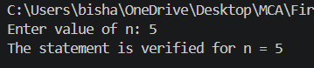

18. WAP in python to represent adjacency list and visualize using NetworkX.
import networkx as nx
import matplotlib.pyplot as plt

graph = {
'A': ['B', 'C'],
'B': ['A', 'D'],
'C': ['A', 'D'],
'D': ['B', 'C']
}

print("Adjacency List:")

for vertex in graph:
print(vertex, ":", graph[vertex])

G = nx.Graph()

for vertex in graph:
for neighbor in graph[vertex]:
G.add_edge(vertex, neighbor)

nx.draw(
G,
with_labels=True,
node_size=2000
)

plt.title("Graph using Adjacency List")
plt.show()
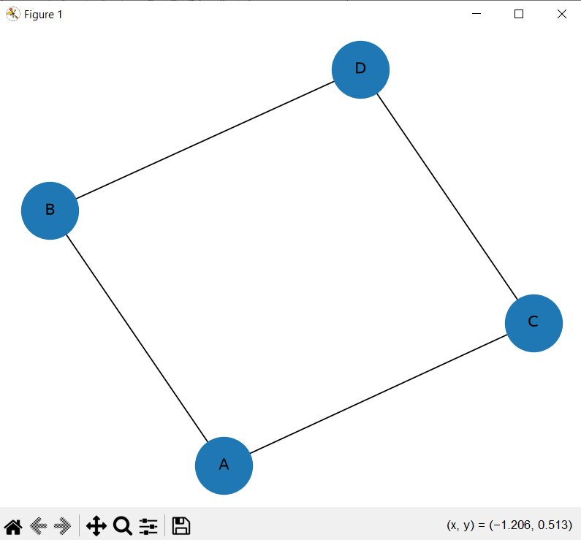

19. WAP In python to represent adjacency matrix and visualize using NetworkX.
import networkx as nx
import matplotlib.pyplot as plt
import numpy as np

vertices = ['A', 'B', 'C', 'D']

matrix = np.array([
[0, 1, 1, 0],
[1, 0, 0, 1],
[1, 0, 0, 1],
[0, 1, 1, 0]
])

print("Adjacency Matrix:")
print(matrix)

G = nx.from_numpy_array(matrix)

mapping = {
0: 'A',
1: 'B',
2: 'C',
3: 'D'
}

G = nx.relabel_nodes(G, mapping)

nx.draw(
G,
with_labels=True,
node_size=2000
)

plt.title("Graph using Adjacency Matrix")
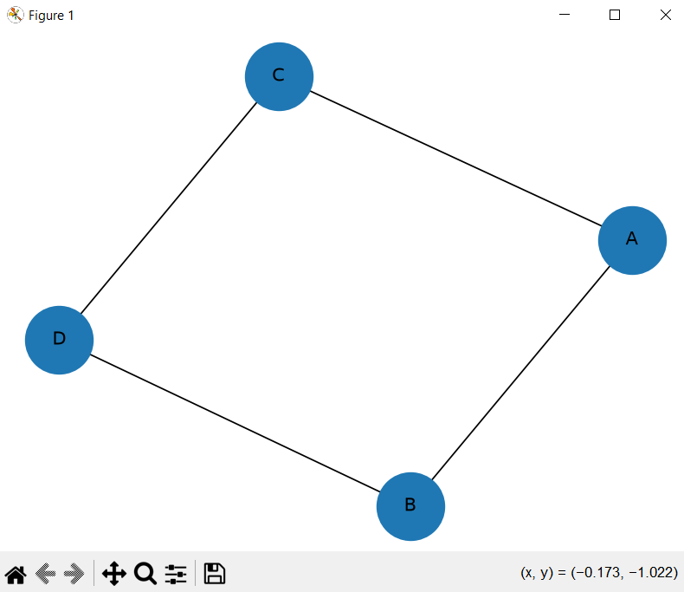
plt.show()

20. WAP in python to perform tree traversal (pre-order, in-order and post-order).
class Node:
def __init__(self, data):
self.data = data
self.left = None
self.right = None

def preorder(root):
if root:
print(root.data, end=" ")
preorder(root.left)
preorder(root.right)

def inorder(root):
if root:
inorder(root.left)
print(root.data, end=" ")
inorder(root.right)

def postorder(root):
if root:
postorder(root.left)
postorder(root.right)
print(root.data, end=" ")

root = Node(1)
root.left = Node(2)
root.right = Node(3)
root.left.left = Node(4)
root.left.right = Node(5)

print("Pre-order:")
preorder(root)

print("\nIn-order:")
inorder(root)
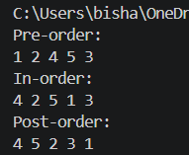
print("\nPost-order:")
postorder(root)

21. WAP in python to find MST using Kruskal’s algorithm.
class Graph:
def __init__(self, vertices):
self.V = vertices
self.edges = []

def add_edge(self, u, v, w):
self.edges.append((w, u, v))

def find(self, parent, i):
if parent[i] != i:
parent[i] = self.find(parent, parent[i])
return parent[i]

def union(self, parent, rank, x, y):
xroot = self.find(parent, x)
yroot = self.find(parent, y)

if rank[xroot] < rank[yroot]:
parent[xroot] = yroot
elif rank[xroot] > rank[yroot]:
parent[yroot] = xroot
else:
parent[yroot] = xroot
rank[xroot] += 1

def kruskal(self):
self.edges.sort()

parent = list(range(self.V))
rank = [0] * self.V

mst = []
total_weight = 0

for weight, u, v in self.edges:
x = self.find(parent, u)
y = self.find(parent, v)

if x != y:
mst.append((u, v, weight))
total_weight += weight
self.union(parent, rank, x, y)

print("Edges in MST:")

for u, v, weight in mst:
print(u, "-", v, ":", weight)

print("Total weight =", total_weight)

g = Graph(4)

g.add_edge(0, 1, 10)
g.add_edge(0, 2, 6)
g.add_edge(0, 3, 5)
g.add_edge(1, 3, 15)
g.add_edge(2, 3, 4)

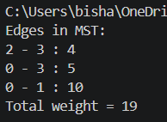
g.kruskal()

22. WAP in python to construct finite automata that accepts strings only ab and abb.
def finite_automata(string):
state = "q0"

for symbol in string:
if state == "q0":
if symbol == "a":
state = "q1"
else:
state = "dead"

elif state == "q1":
if symbol == "b":
state = "q2"
else:
state = "dead"

elif state == "q2":
if symbol == "b":
state = "q3"
else:
state = "dead"

elif state == "q3":
state = "dead"

else:
state = "dead"

if state == "q2" or state == "q3":
return True
else:
return False

string = input("Enter a string: ")

if finite_automata(string):
print("Accepted")
else:
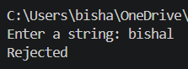
print("Rejected")

